CLIENT EVALUATION FORM
& MEDICAL HISTORY

Patient Name: ______________________________________ Date: ____________________
Address: _____________________________________________ Phone: _________________
City: _____________________________ State: __________ ZIP: _____________________ Emergency#_______________________ Date of Birth: _________________________
Email: ____________________________________
We respect your privacy and will only use these addresses for clinic news and information.

Primary concern:

What are your symptoms?

When did your symptoms begin?

How did your symptoms occur?

Any surgeries? Yes No
Type and Date of surgery:

Do you have any scars on your body and where?

Are you pregnant? Yes No

What tasks are you having difficulty performing (bending, lifting, standing/sitting, reaching)?

Pain Level (0/10 = no pain, 10/10 is worst pain imaginable):

Where is the pain located?
Current pain level?
Best in last 2 weeks?
Worst in last 2 weeks?

IMPORTANT: Please Shade Areas of Pain or Discomfort Below:

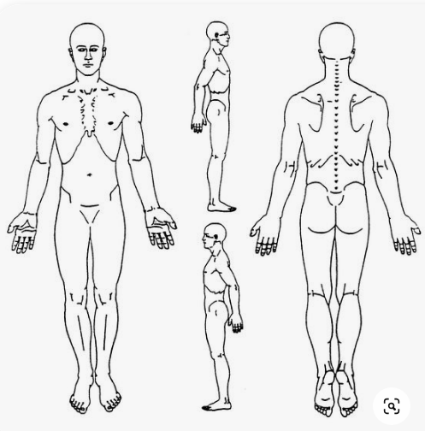

Blood Pressure: High Low Normal

Digestion: Regular Irregular: Too slow Too fast
Food sensitivities or modification:
Prescriptions or herbs:

Menstruation: Regular Irregular Painful Strong Weak
Sleep: Hours per night: Wake: Bedtime:
Current forms of exercise:

Have you ever been diagnosed with condition/disorder/syndrome?

What are your goals for treatment?
Be specific on how you want to feel and what you would like to see yourself doing more of.

Do you have any time expectations?

What is your commitment level to reaching your treatment goals on a scale of 1 to 10 (with 1 being close to none and 10 being 110% in)?

